**EX:No.3 STATIONARITY CHECK 221501040 04/03/25**

**AIM :** To implement stationarity check using Augmented Dickey Fuller test and Visualise it.

**PROCEDURE:**

1. Read the time-series data from the CSV file.

2. Convert the date column to datetime format and set it as the index.

3. Visualize the data using a line graph.

4. Apply the Augmented Dickey-Fuller (ADF) test to check stationarity.

5. Print the ADF statistic, p-value, and critical values.

6. Determine if the series is stationary based on the p-value.

**IMPLEMENTATION :**

import numpy as np

import pandas as pd

import matplotlib.pyplot as plt

from statsmodels.tsa.stattools import adfuller

# Load your data

df = pd.read_csv("cleaned_sales_data.csv", index_col="Order Date", infer_datetime_format=True, parse_dates=True)

# Plot the original time series

plt.figure(figsize=(12, 6))

plt.plot(df["Sales"], label="Sales")

plt.title("Sales Data Over Time")

plt.xlabel("Date")

plt.ylabel("Sales")

plt.legend()

plt.show()

# Calculate and plot rolling statistics

rolling_mean = df["Sales"].rolling(window=30).mean()

rolling_std = df["Sales"].rolling(window=30).std()

plt.figure(figsize=(12, 6))

plt.plot(df["Sales"], label="Original Sales")

plt.plot(rolling_mean, label="Rolling Mean", color='red')

plt.plot(rolling_std, label="Rolling Std Dev", color='black')

plt.title("Rolling Mean & Standard Deviation")

plt.legend()

plt.show()

# Augmented Dickey-Fuller Test

def adf_test(series):

result = adfuller(series.dropna())

labels = ['ADF Statistic', 'p-value', '# Lags Used', 'Number of Observations']

for label, value in zip(labels, result[:4]):

print(f"{label}: {value}")

print("Critical Values:")

for key, value in result[4].items():

print(f"{key}: {value}")

if result[1] <= 0.05:

print("\nData is stationary (reject H0).")

else:

print("\nData is non-stationary (fail to reject H0).")

print("ADF Test on Original Sales Data:")

adf_test(df["Sales"])

# Apply differencing if needed

df['Sales_Diff'] = df['Sales'].diff()

# Re-plot after differencing

plt.figure(figsize=(12, 6))

plt.plot(df['Sales_Diff'], label="Differenced Sales")

plt.title("Differenced Sales Data")

plt.xlabel("Date")

plt.ylabel("Differenced Sales")

plt.legend()

plt.show()

print("\nADF Test on Differenced Sales Data:")

adf_test(df['Sales_Diff'])

**OUTPUT:**

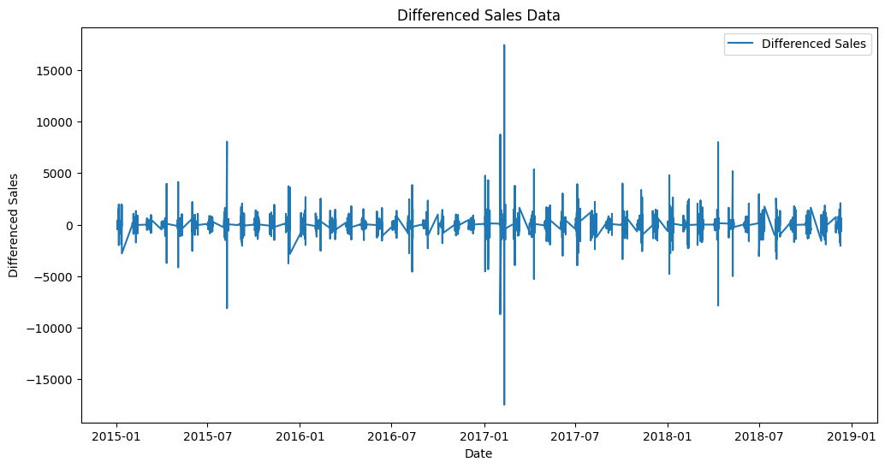

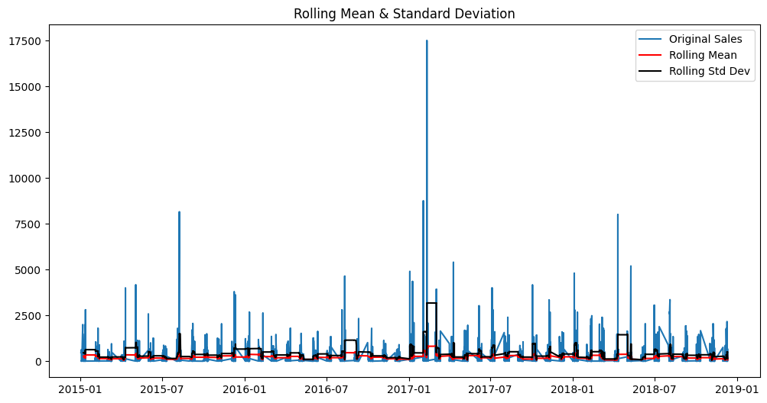

**ADF Test on Original Sales Data:**

**ADF Statistic: -61.737484433108676**

**p-value: 0.0**

**# Lags Used: 0**

**Number of Observations: 3958**

**Critical Values:**

**1%: -3.4320032456041702**

**5%: -2.8622705134633857**

**10%: -2.5671588604603004**

**Data is stationary (reject H0).**

**RESULT :** Thus stationarity check has been implemented successfully using Augmented Dickey Fuller Test.